Trading Partner Integration (B2B/EDI) on Azure
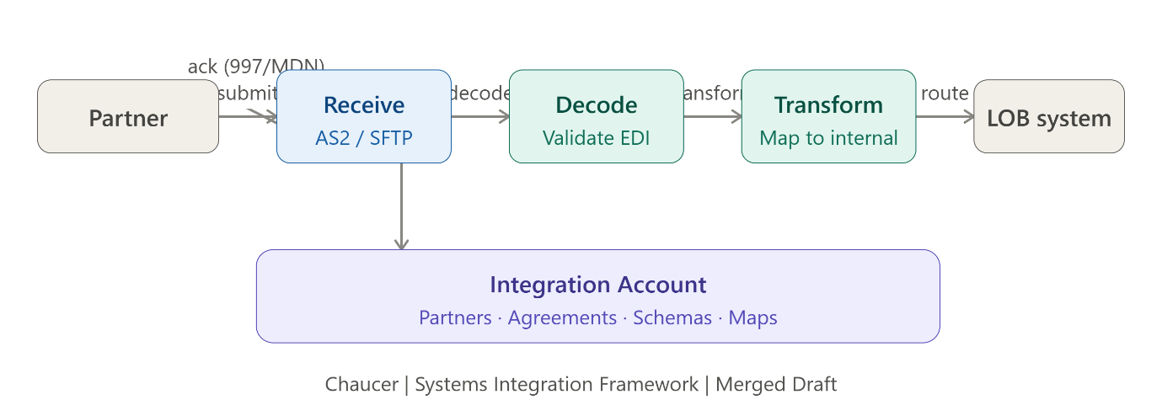

Problem Context
Organizations exchange business documents such as purchase orders, invoices, shipment notices, and claims with external partners using different protocols and formats (AS2, SFTP, X12, EDIFACT, XML, JSON, CSV). Direct partner-to-application integrations lead to:
- Point-to-point dependencies
- Partner-specific custom code
- Security and certificate management challenges
- Limited visibility and tracking
- Difficult onboarding and maintenance
The objective is to create a governed, secure, and reusable integration layer between external trading partners and internal enterprise applications.

Solution Approach

Key Processing Steps
- Receive partner message securely.
- Identify partner and agreement.
- Validate schema, envelope and security.
- Generate protocol acknowledgements (MDN, 997, TA1, etc.).
- Transform to internal canonical format.
- Publish to Service Bus for reliable processing.
- Route to downstream business systems.
- Monitor, track, retry and reconcile transactions
Azure Components Involved
Component | Purpose
Azure Logic Apps Standard | B2B orchestration and workflow execution
Azure Integration Account | Partners, Agreements, Schemas, Maps, Certificates
Use It When
✅ Multiple trading partners require different protocols or document standards.
✅ EDI/B2B standards such as X12, EDIFACT, or AS2 are required.
✅ Partner-specific agreements, schemas and mappings must be centrally managed.
✅ Technical acknowledgements (MDN, 997, TA1) are mandatory.
✅ Reliable asynchronous processing and replay capabilities are needed.
✅ Partner onboarding should be configuration-driven rather than code-driven.
✅ End-to-end transaction visibility and auditability are required.

Avoid It When
❌ Simple internal API-to-API integration.
❌ Direct REST/JSON integration with minimal transformation.
❌ Low-volume, single-partner integrations where EDI governance is unnecessary.
❌ The architecture adds more operational overhead than business value.

Risks & Considerations
Operational
- Certificate expiry can disrupt partner communication.
- Partner onboarding requires rigorous testing and agreement validation.
- Misconfigured partner identifiers can cause routing failures.
Reliability
- Duplicate transactions require idempotency controls.
- Out-of-order processing may require Service Bus sessions.
- Poison messages need dead-lettering and retry policies.
- Reliable acknowledgement generation is critical.
Scalability
- Large payloads should use Blob Storage and Claim Check pattern.
- Integration Account sizing impacts cost and partner capacity.
Governance
- Canonical models should remain domain-focused.
- Mapping and routing rules should be configuration-driven.
- Replay processing must prevent duplicate business impacts.

Security Boundary
External Zone
- APIM, AS2, SFTP or WAF-protected endpoints exposed externally.
- Mutual TLS, OAuth, certificates and partner authentication enforced.
- All inbound messages treated as untrusted
Azure Integration Zone
- Logic Apps, Service Bus, Storage, SQL and Key Vault remain behind controlled networking.
- Use Managed Identity, RBAC, Private Endpoints and VNet Integration.
- Partner certificates managed centrally .
Enterprise Zone
- Internal systems only communicate through approved integration identities.
- No direct partner access to ERP, databases, queues, file shares or Key Vault.

Common Anti-Patterns
❌ Direct partner access to ERP systems or databases.
❌ Building separate integrations for every trading partner.
❌ Hardcoding partner IDs, routes, credentials or mappings.
❌ Sharing certificates across partners.
❌ Treating transport acknowledgements as business acceptance.
❌ Storing oversized messages directly in Service Bus.
❌ Infinite retries for permanent validation failures.
❌ Logging full business payloads in monitoring tools.
❌ Using APIM for orchestration instead of Logic Apps.
❌ Replaying transactions without idempotency controls.
❌ Passing unvalidated partner payloads directly to downstream systems.

One-Line Architecture Summary
Azure Logic Apps + Integration Account provide a secure, standards-based B2B gateway that validates partner agreements, transforms EDI/business documents into canonical formats, and reliably delivers them to enterprise applications through Service Bus while maintaining security, auditability, and operational governance.

